Game Meat / Viande de gibier
Kangaroo / Kangourou
Sausage Sticks / Bàtonnets de saucisssons

Ingredients: Domestic kangaroo, Pork, Beef, Sea salt, Sugar (maple syrup), Cultured celery powder, Pepper, Garlic, Starter culture, Olive oil, Natural wood smoke.
Ingredients: Kangourou domestique, Porc, Bœuf, Sel de mer, Sucre (sirop d’erable), Poudre de céleri de culture, Poivre, Ail, Culture starter, Huile d’olive, Fumée de bois naturel.

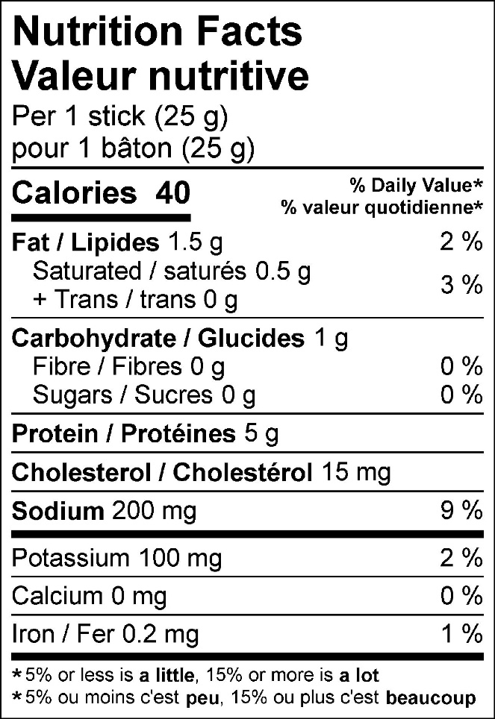

50 g (2-pack) 125 g (5-pack)


